





Instructor:

[**Phillip Burton**](https://www.udemy.com/course/oracle-sql-an-introduction-to-the-most-popular-database/)

Best Selling Instructor

Owner:

[**Azamat**](https://t.me/Azamat_Nishonov)[**Nishonov**](https://t.me/sql_portfolio_24)

SQL Developer

Content

USTANOVKA 3

1. Oracle Express Edition ni yuklash va o’rnatish. 3

2. Oracle SQL Developer ni yuklash va o’rnatish. 4

3. Connect to Database 4

SELECT, FROM 5

ALIASES 7

COMMENT 8

WHERE 8

GROUP BY 9

HAVING 10

ORDER BY 10

So’rovlar tartibi 11

Xatoliklar uchun havolalar 11

# USTANOVKA

## 1. Oracle Express Edition ni yuklash va o’rnatish.

1. Razryadni aniqlaymiz.

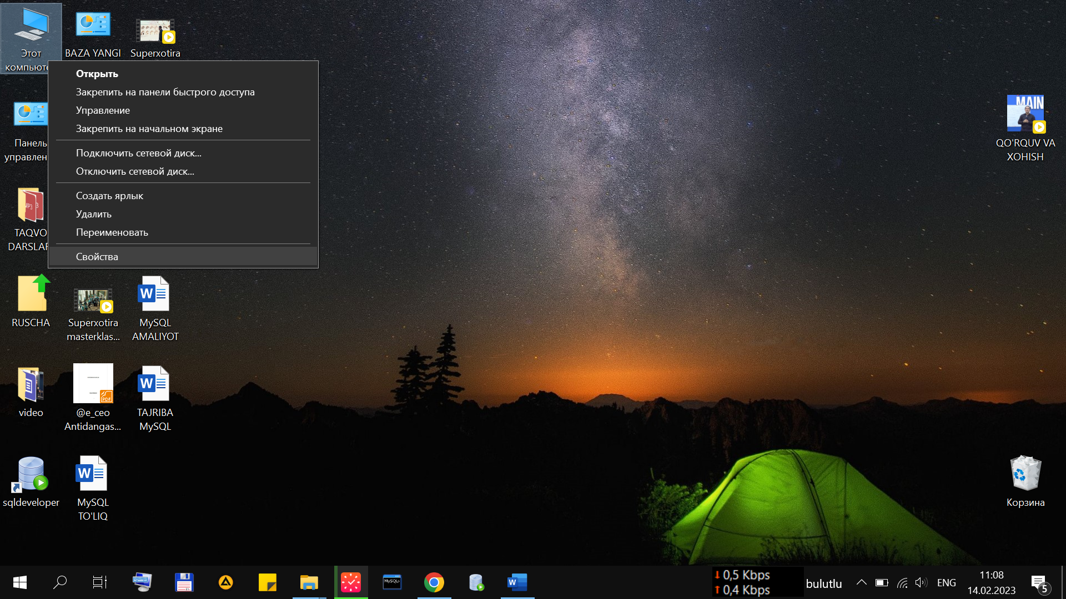 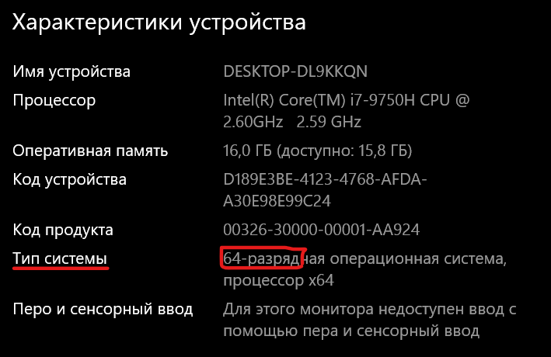

1. Link bilan saytga o’tish. <https://www.oracle.com/downloads/>
2. 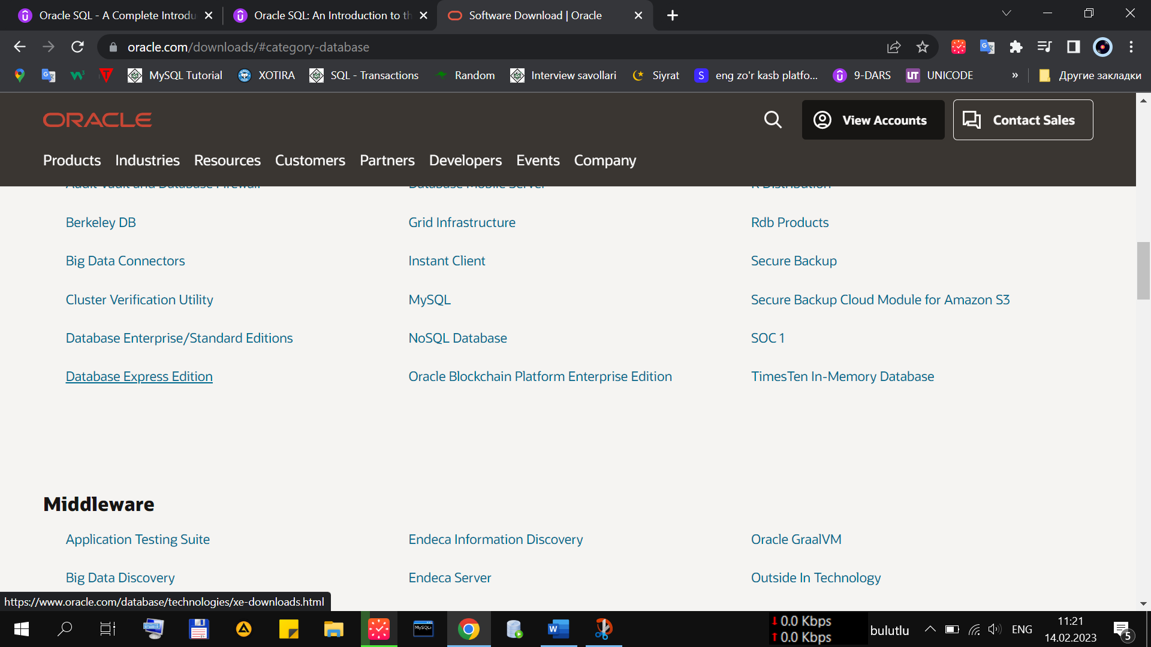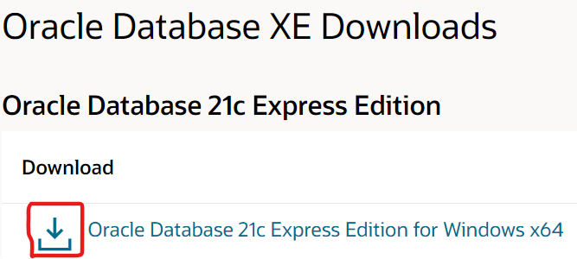Yuklab olish.
3. Yuklangan faylni o’rnatish

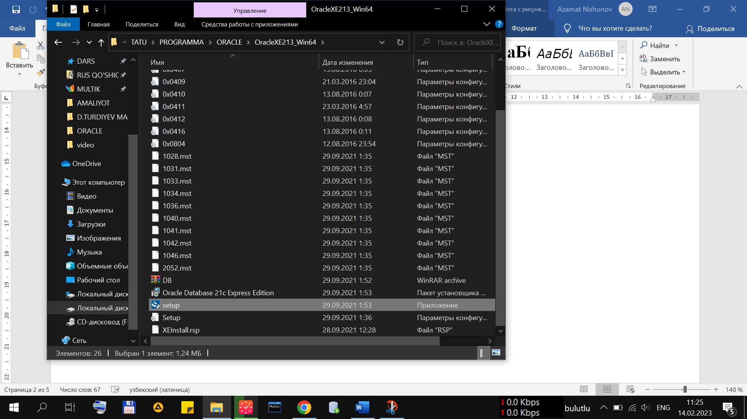

1. 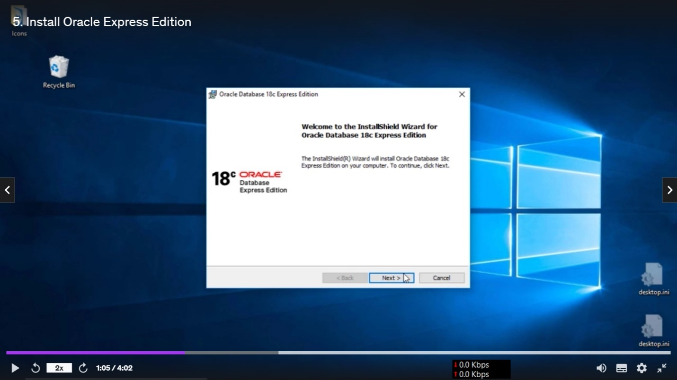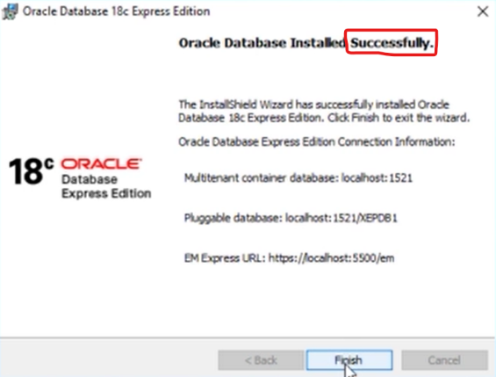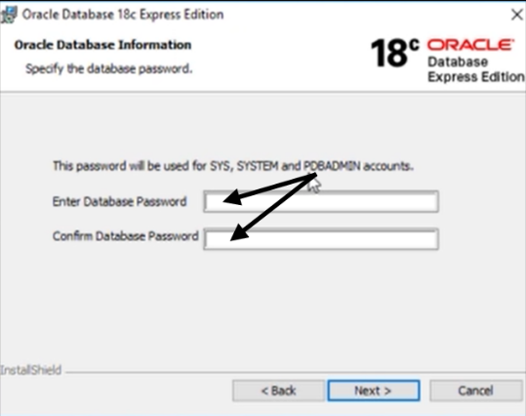O’rnatish jarayoni.

## 2. Oracle SQL Developer ni yuklash va o’rnatish.

1. Oracle Sql Developer Download deb qidirish.



1. Yuklab olish.

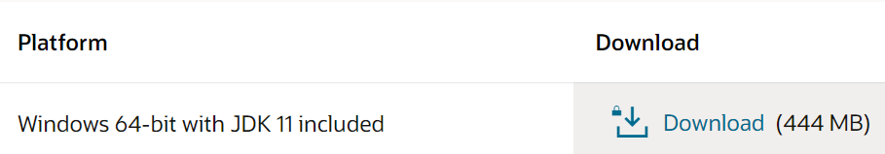

1. 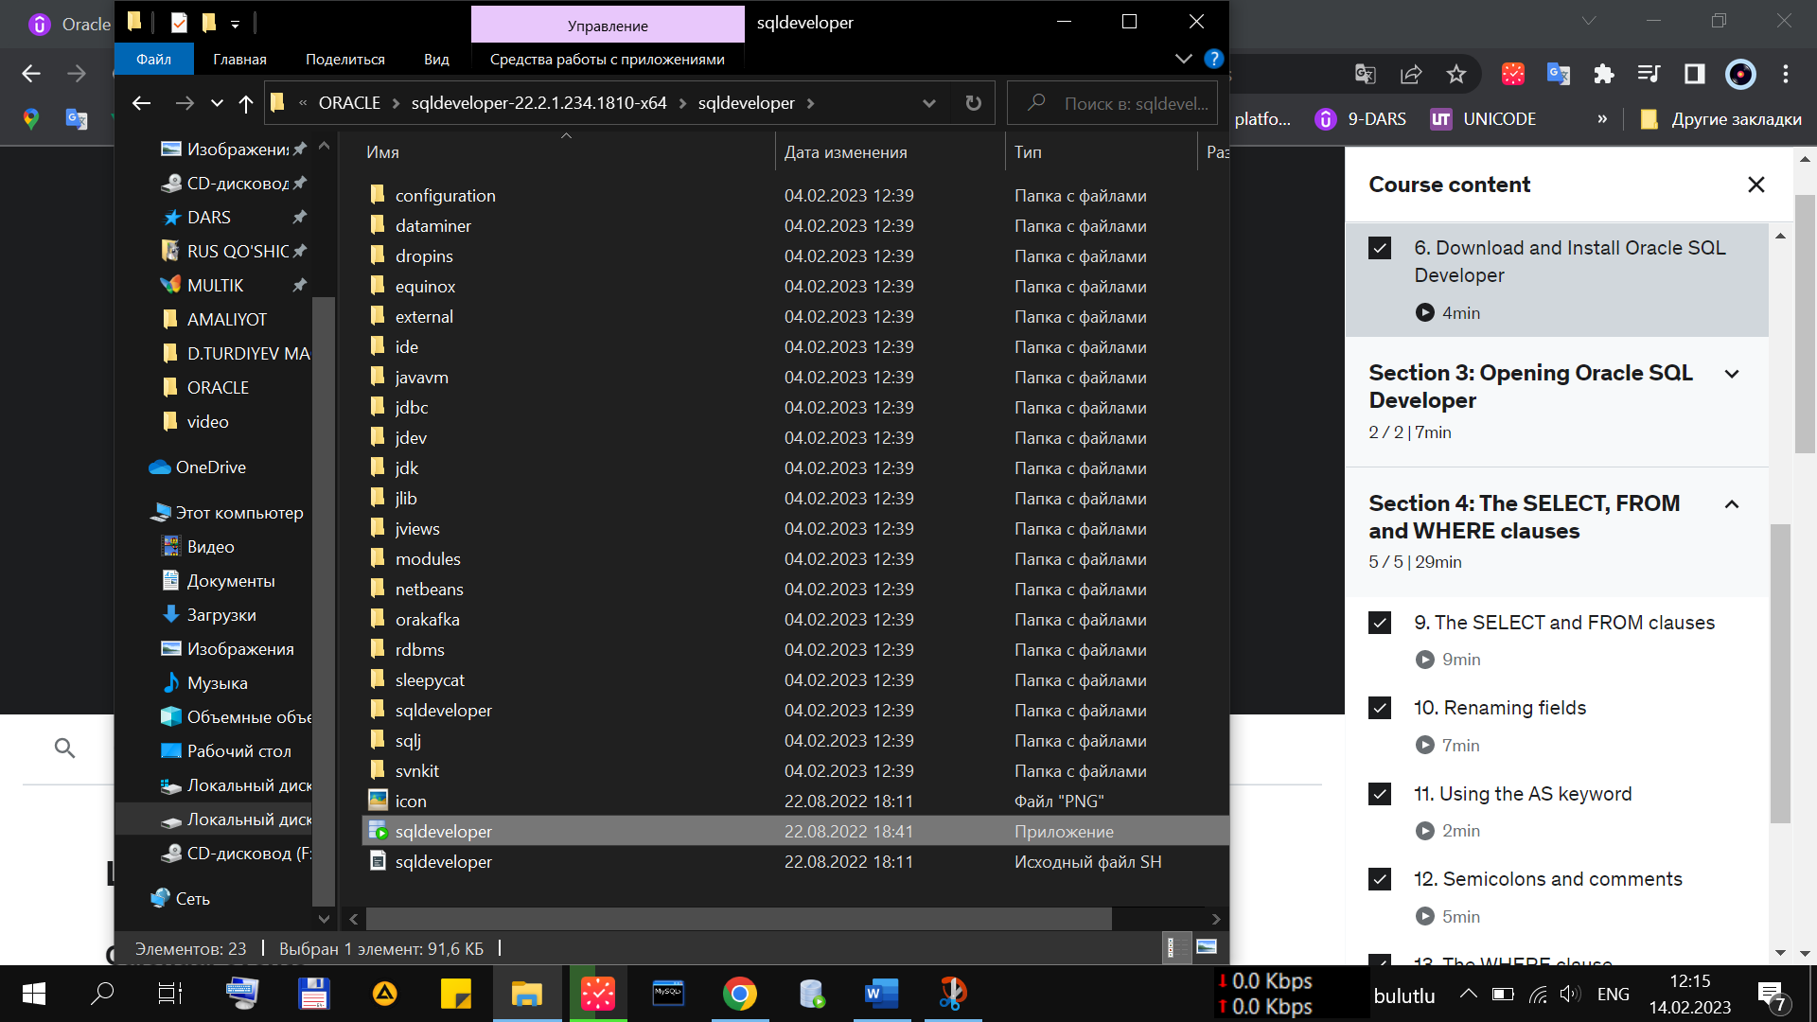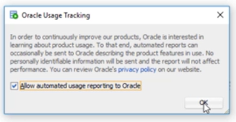O’rnatish

## 3. Connect to Database

1. Create new database
2. 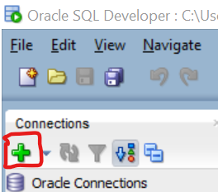Baza nomi ixtiyoriy, username: SYS, password: ixtiyoriy, keyinchalik o’zgarmas. Color qismidan rang tanlanadi.

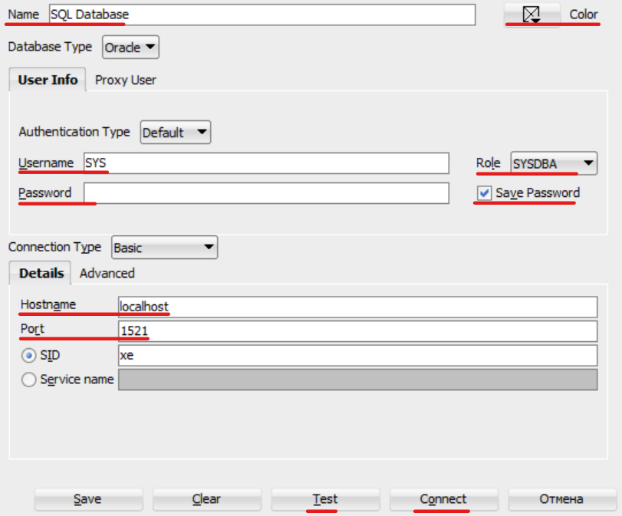

1. Test bosiladi. Status: Success

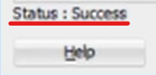

1. Connect bosiladi.

# SELECT, FROM

1. + bosiladi

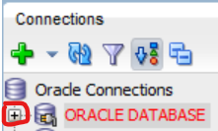

1. + bosiladi

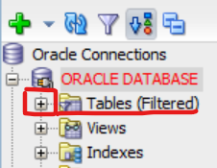

1. Select bayonoti. (*) barchasi degan ma’noni bildiradi.

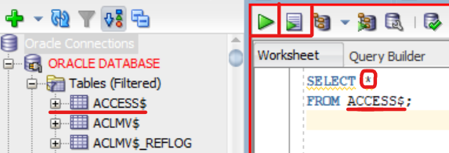 => Run [Ctrl+Enter], (Tanlangan kod ishga tushadi)

 => Run Script [F5] (Barcha kodlar ishga tushadi)



1. Jadval ustunini selectga olib borish

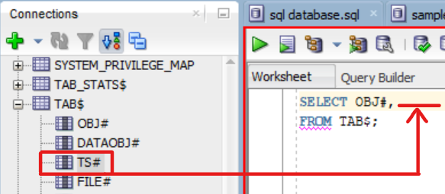

1. Object name bosiladi

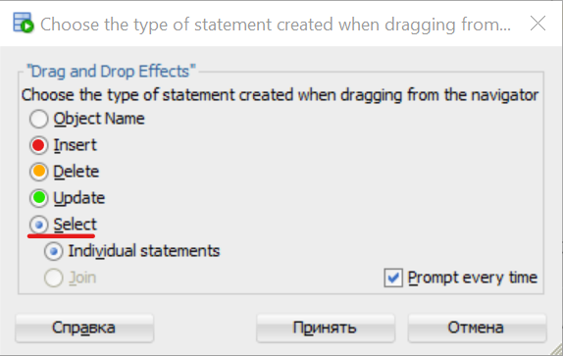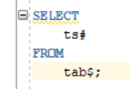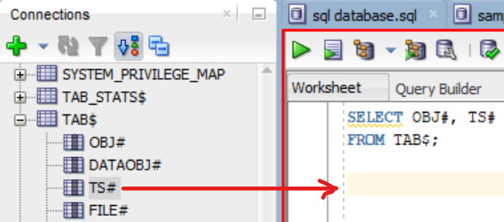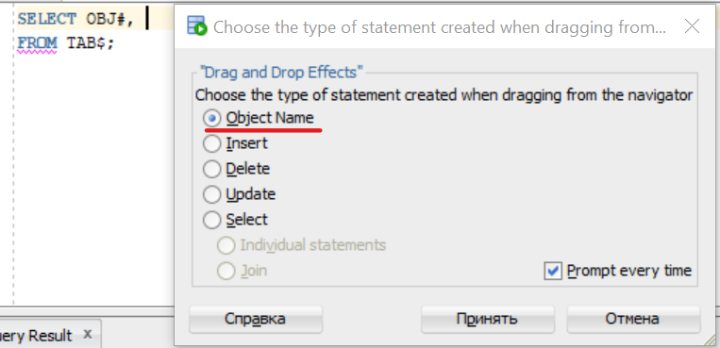

1. Avtomatik so’rov yaratish

# ALIASES

AS Taxallusining 2 xil ko’rinishi

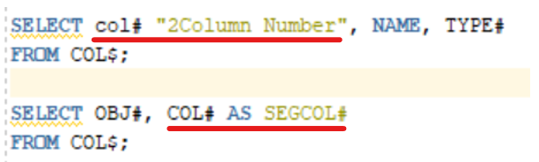

Quoted identifier (keltirilgan identifikator) – probel, raqam, belgi bilan boshlansa yoki so’rovning kalit so’zlari bo’lsa [Qo’shtirnoq ichiga yoziladi] 🡪 **“ … “**

Non-quoted identifier – harf, raqam, [ $, _ , # ]. 1-30 belgilar

Oracleda 2ta so’rovni bir paytda bajarish:

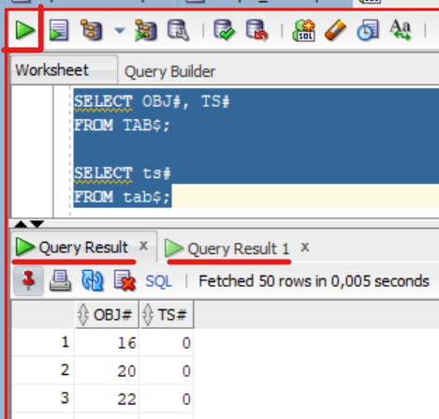

# COMMENT

Komentariya 1 qator uchun -- Ctrl + / [yoqish / o’chirish]



Komentariya ko’p qator uchun /* … */ ishlatiladi

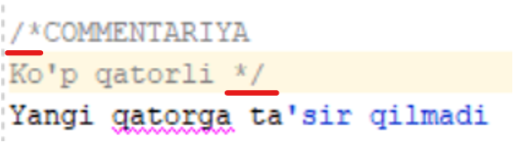

# WHERE

Where so’rovida filter va tartiblash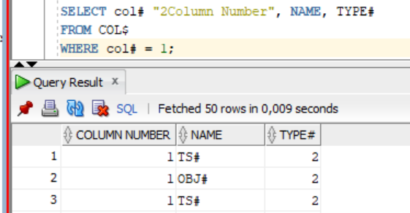

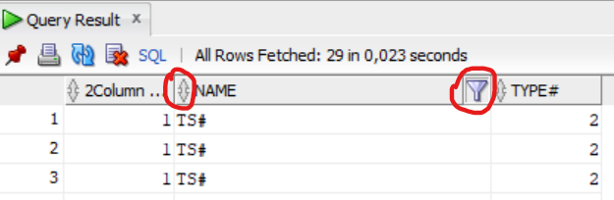

1. Harf va raqam bo’yicha tartiblaydi
2. So’zlar va sonlarni filtrlaydi

# GROUP BY

*GROUP BY* orqali *NAME*ning takrorlanishlar sonini chiqarish:

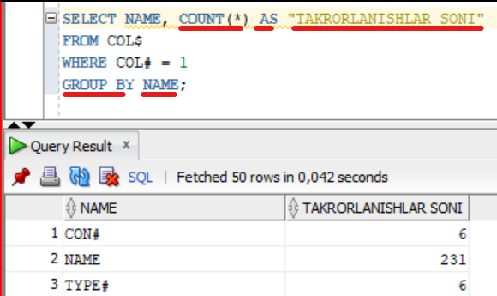

Bitta tipda bo’lishi kerak

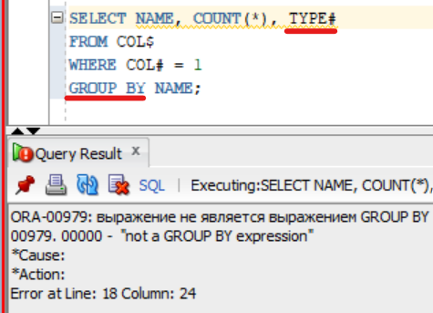

*TYPE* ni *GROUP BY* ga qo’shdik

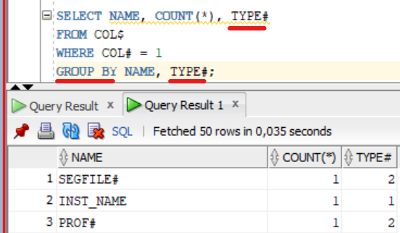

# HAVING

5 qatordan ortiq takrorlangan nomlarni chiqarish

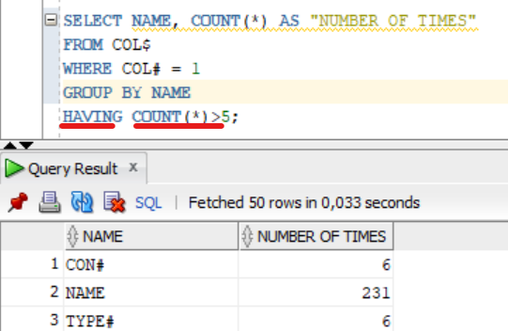

# ORDER BY

*ORDER BY*  tartiblab chiqaradi. Ustunni taxallusi bilan chaqirsa ham bo’ladi.

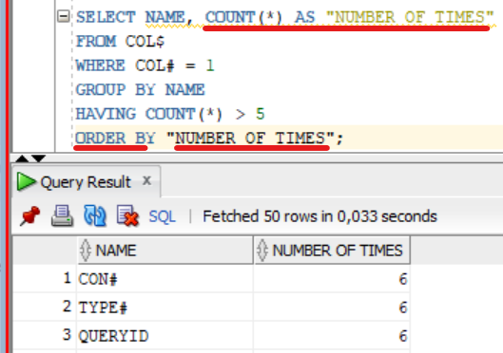

*ORDER BY* bilan teskari tartiblash *DESC*

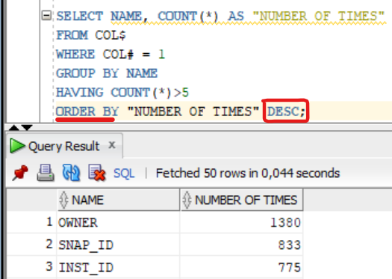

ASC => ASCENDING - ascending order => O'sish tartibi

DESC => DESCENDING - descending order => kamayish tartibi

# So’rovlar tartibi

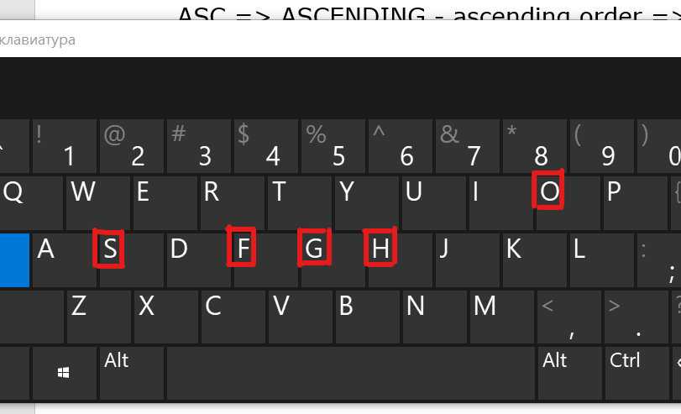***SELECT*** => S

***FROM*** => F

***GROUP******BY*** => G

***HAVING*** => H

***ORDER******BY*** => I

# Xatoliklar uchun havolalar

<https://www.techonthenet.com/oracle/errors/index.php>

<https://docs.oracle.com/database/121/ERRMG/toc.htm>

[**Phillip Burton**](https://www.udemy.com/user/aquaviola/) kurslari <http://idodata.com/sql/>